NewSearch 4Release 2.0

is a unique program for searching the complete theological Writings of the New Church and much collateral literature. NewSearch 4 has many new features and databases (or document collections) when compared to NewSearch98 which it replaces.

Release 2.0 includes both volumes of the translation “True Christianity (Rose)”, three more years of “New Church Life”, additional years of “Theta Alpha Journal” and more Books and Monographs.

Release 2.0 also fixes all known bugs in the first release.

Release 2.0 is available as a free download for those who bought the first release and is for sale at the General Church Bookroom or for download. Please see support site www.newsearchsupport.org.

Searching features of NS4 include:

- Word and phrase searching in Swedenborg’s works and collateral literature
- Full Boolean and proximity searching
- Wildcard searches
- Direct searches for Biblical references (Using a more comprehensive Searle’s Index)
- Several optional ways to rank the list of results: relevance, alphabetical, and date of publication.

Searchable databases include:
- Multiple translations - including many new ones - of Swedenborg’s theological works
- Original Latin of Swedenborg’s theological works
- “New Church Life” (1881-2010) with special search features (in addition to word search):
- Collateral books and Monographs – 110 titles by New Church authors.
- “Theta Alpha Journal” (1910 - 2010)
- “Journal of Education” (1901 – 1990)
- New Church translations of the Pentateuch and the New Testament
- A sampling of Swedenborg’s scientific and philosophical works (Pre-Revelatory)

NewSearch 4 does not contain the text of the Old Testament. This is because there are numerous Bible search programs available that have extensive features which we cannot replicate. A good searcher can be found at: www.crosswalk.com However, we have included the Pentateuch – a New Church translation of the first five books of the Old Testament and A New Church (Kempton) translation of the New Testament. These are found in the in the database called “NC Translations”

When you open the CD (Using Windows Explorer from ‘My Computer’) you will find the following files: NS4_R2_Setup and NS_Manual. NS4_R2_Setup is used to install NewSearch 4 Release 2.0 (see page 3 below for details).

If you are downloading from www.newsearchsupport.net you will find the same files as on the CD.

NewSearch 4 is produced by the STAIRS (Swedenborgian Theological Automated Information Retrieval System) Project, a group at Bryn Athyn College Theological School. The Team: Programming Mr. Chad Rogers, Texts Rt. Rev. Brian Keith, Theological School Dean Rev. Dr. Andrew Dibb, Rev Eric Carswell, Director and Programmer Dr. Charles Ebert. This work has been generously supported by the Carpenter Fund of the Academy of the New Church.

To give feedback or for technical assistance, please check the project website – www.NewSearchSupport.net. This site will allow you to report bugs, ask for assistance or download bug fixes or program updates. If that is not satisfactory, please call Charles Ebert at 303-926-1558 US Mountain Time (GMT-7).

The STAIRS project assumes that users are generally familiar with Windows. If there are problems using the standard Windows features, please consult you computer vendor or systems administrator.

TABLE OF CONTENTS

How to Install NewSearch 4 Release 2.0 3
Quick Guide to Using NewSearch 4 Release 2.0 5
Searching ……………………………………………………………………………………............7
Detailed Operating Instructions…………………………………………………………………….14
Pull Down Menus……………………………………………………………………14
File …………………………………………………………………………………..14
Edit …………………………………………………………………………………. 14
Options ………………………………………………………………………………14
View …………………………………………………………………………………21
Additional Text Windows …………………… ……………………………………..22
Biblical Reference …………………………………………………………………...22
Search Results Window ……………………………………………………………...23
Text Window………………………………………………………………………....23
Printing Text …………………………………………………………………………………..........24

Discussion of Sacred and Collateral Texts …………………………………………………………25
Appendix A – Translators, Dates and Locations of Works ………………………………………...39
Appendix B – Lists of the Writings ………………………………………………………………...44
Appendix C – Comparison of Number in Last Judgment Posthumous …………………………....48
Appendix D – Marriage Indices …………………………………………………………………....50
Appendix E – Subjects in Prophets and Psalms ……………………………………………………52
Appendix F – Prophets and Psalms Numbering ……………………………………………………53
Appendix G –Titles and Dates of the Pre Revelatory Works ………………………………………54

HOW TO INSTALL NEWSEARCH 4 Release 2.0
(From a CD or from the NewSearch Support site)

1) From the CD copy NS4_R2_Setup to the desktop of your computer. If you have previously purchased NewSearch 4, you may download the installer for Release 2.0 from the web site: www.NewSearchSupport.net.
Note: You will need at least 2000 MB of free space on your hard drive to install NewSearch 4. You will need Windows XP (Service Pack 2) or newer.

NOTE: If you are using Windows 7:
- To install you need to right click on NS4_R2_Setup and choose “Run as administrator”.
- To run you need to right click on the icon and “Run as administrator”.

2) Remove (uninstall) any previous versions of NS4 that you might have had:
(Windows XP) START -> CONTROL PANEL -> ADD-REMOVE PROGRAMS. Find NS4 in the list and remove it.

(Windows 7) START -> CONTROL PANEL -> PROGRAMS AND FEATURES. Find NS4 in the list and remove it.

This may take some time. (Note: if you have NewSearch 98 on your computer, you do not have to uninstall it.)

3) From your desktop, double click NS4_R2_Setup - this will launch the install program. Note: It takes 15 – 30 minutes to install NewSearch 4
NOTE: In order to get the install to work on all computers, we had to include the installation of a module called “Microsoft Visual C++ 2005 Redistributable”. The installation of this item is launched automatically after you click “finish” to the installation of NS4. A license agreement then appears on the screen. Just click “Yes”. After that it will finish, but it does not give a “Finish” screen. When everything vanishes the installation is complete. Please see below for the appropriate screen shots.

4) Click as needed to keep the install going.

5) When the installer is finished, your start menu should have NewSearch 4 in it. You may have to check the All Programs menu for it the first time.

Figures 1-4 show the screens you will see in the Install Process:

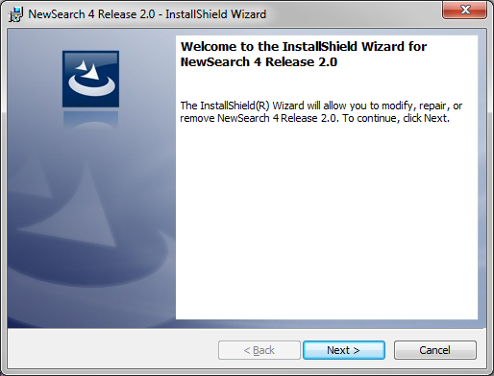
Figure 1 - First Install Screen

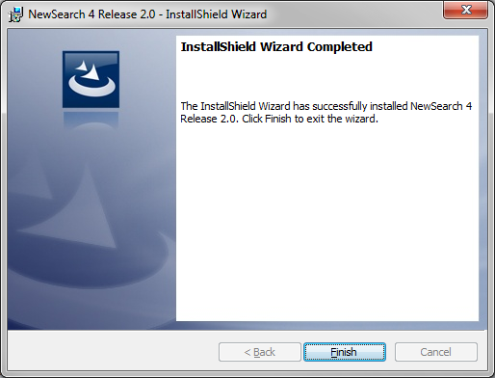
Figure 2 - Completion of Initial Install

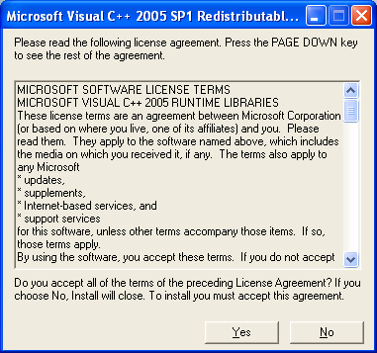

Figure 3 - License Agreement

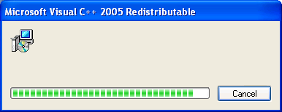

Figure 4 - Final Install Screen

Then all vanishes and the setup is complete.

QUICK GUIDE TO USING NEWSEARCH 4

To launch NewSearch 4, find the NewSearch icon in the start menu or the All Programs menu and double click If you are using Windows 7 or Vista, you may need to right click and select “run as administrator.” You may notice that the first time you use a document collection (Writings, New Church Life, etc.), that the searching is a bit slow. It should speed up the next time you use that document collection.

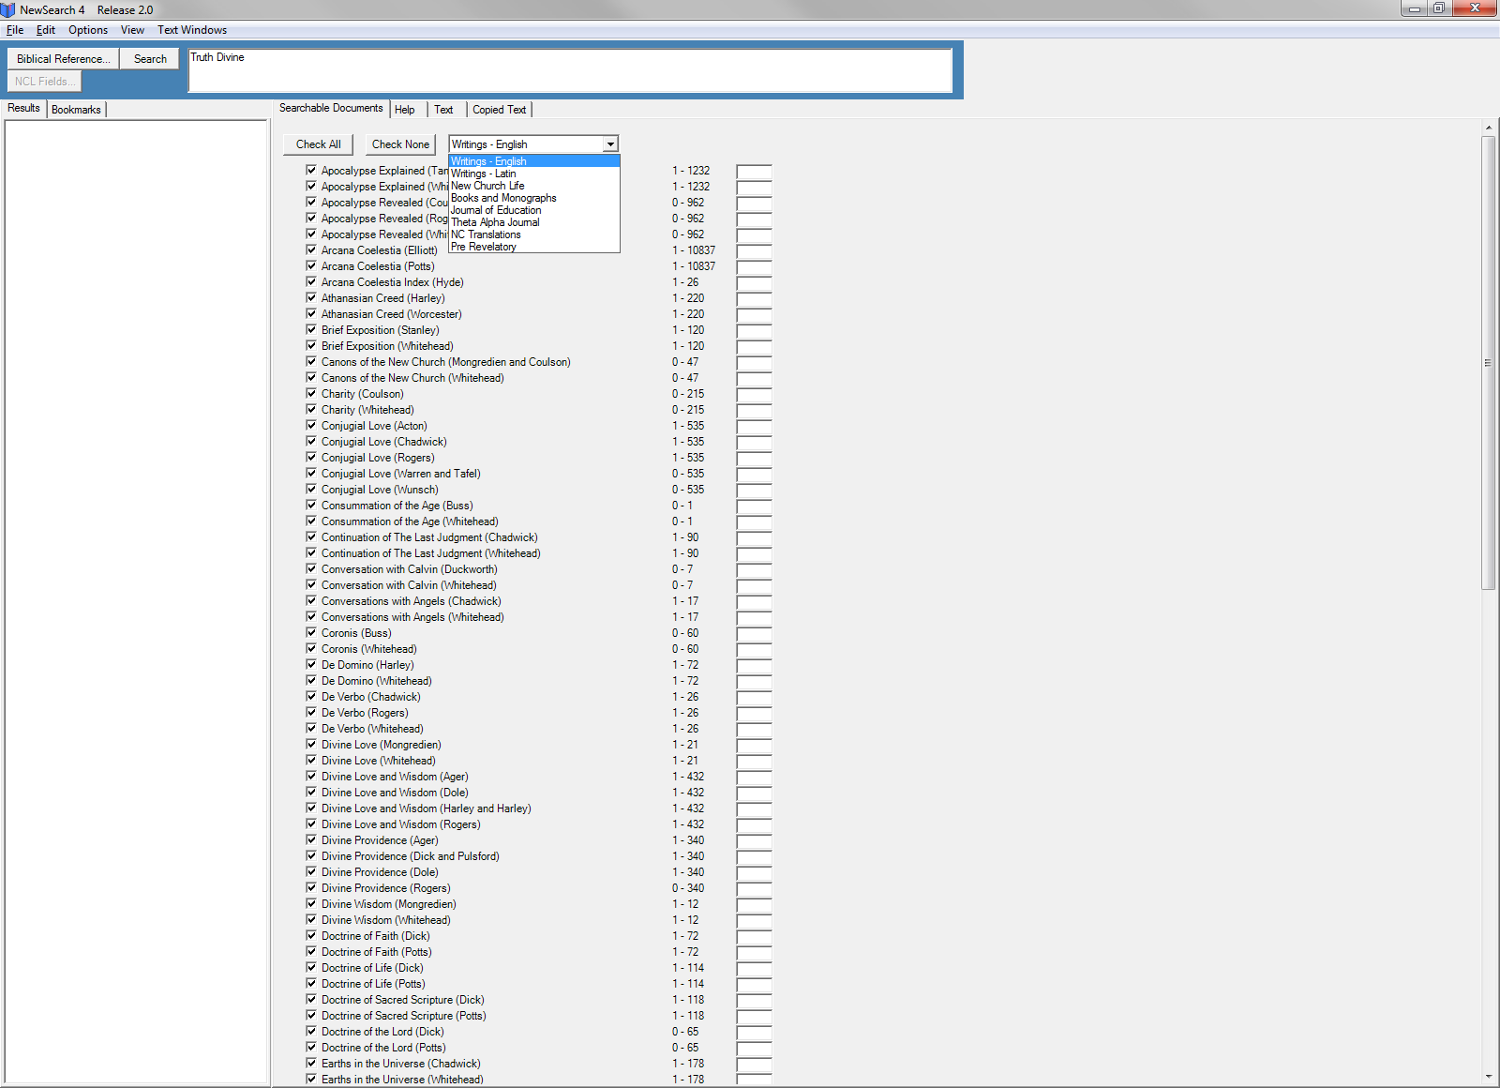
Figure 5 - Initial Window with Document Collection Choice Shown
Searching:

- Pick a database from the “Searchable Documents” window pull down menu, immediately after the list of titles. It defaults to “Writings – English” (Figure 5)

- Word search. Enter a word or sequence of words. A sequence of words is taken to be an exact phrase (where you would have used quotes in NS98). You may use wildcards (*) or Boolean logic (and, or, not, etc.) and click the Search button. The Results window (on the left) gives you a list of choices. Double click your choice and the text is displayed with the search words highlighted. Searches are not case sensitive. See the Help tab for more details for searching.

- Biblical Reference (Searle’s Index) is available only when the “Writings – English” database is selected. Click the Biblical Reference button in the search window. Select the book and enter a chapter number and optional verse number. This puts an entry into the search window. You still have to press Search. You may also add search terms.
- Searching New Church Life. Select the New Church Life database. All the standard means of searching can be used, or you may select the “NCL Fields.” This brings up a window that allows you to filter by type (sermon, article, etc.), author or title. You may add search terms and then hit Search. You may also just click Field Only Search and get all the documents in those categories. For example, if you choose author = Acton, Rev. Elmo and type = sermon and then click Field Only Search, you will get all of his 12 sermons that are in NCL. You don’t have to use the NCL Fields option. You can just enter search words in the search form and it will work as all the other databases.
- The boxes to the immediate left of the titles enable you to search all books or just those you check.

- Note: When viewing the text window after a search in “Theta Alpha Journal” or “Journal of Education”, the title and author may not appear. Just click the Previous Page button until you get to the top of the article.

Reading

If you want to read a specific passage (or page – depending on which collection is chosen), just enter the passage number in the box at the end of the title of the work and select Enter on your keyboard. The Reading option is not available with New Church Life or the New Church Scripture Translations. Ranges of passage or page numbers are given for what is contained in the texts. There is also the option, depending on the collection, of sorting the works by title, author (Books and Monographs), date written and date published (Writings). Go to Options/Document Selection Sort Order to do this.

Copying and Saving Text:

When a text window is open, highlight the text you want to save (or select all (Ctrl-A) to capture the entire passage) and press the “control” (Ctrl) and “s” keys. This saves the text in the tabbed area entitled “Copied Text.” Or, “control” and either “c” or “s” will save it on your clipboard and it can be copied immediately into a word processing document.

To save text from the tabbed area “Copied Text” to your hard drive, click the Save Document button at the top of that window. The copied text will be saved under My Documents as Copied Text 1.rtf. What is currently in the copied text tab is what is saved. It does not append to what was already there. To change the target folders and file names see below under “Copied Text Options”. Clicking “Copy Document To Clipboard” does just that. It will then be available to be pasted elsewhere. See below for details.

SEARCHING

NewSearch 4 has a wide variety of searching capability and databases. This section will take you through some descriptions – with screen images – of some of the major searching techniques. The best way to learn is to experiment.

The Opening Screen: When NewSearch 4 is launched, you get the screen in figure 5 with one difference: in the image the database choice pull down list is shown. The default database is the Writings-English (all translations included).

The search process:

- From the “Searchable Documents” screen, select the desired data base from the pull down menu. The searching techniques for all the databases except “New Church Life” (NCL) are very similar. NCL will be described separately.
- For any given database, you may choose to search all the documents – for example all the Writings in English. This is the default. By checking and un-checking the boxes shown, you may select which works will appear in the results list. While all documents are searched each time – checking the boxes limits which works appear in the results list. When there are multiple translations, the unchecked works are still available using the “Next Translation” button.
- Enter search targets and select “Search” or “Enter.” Directions for complex searching and examples are found in the help tab.
- The passage results are listed in the “Results” window on the left. The text of the first result appears in the “Text” window on the right. You can also select any passage on the left and its text will appear in the “Text” window. The targeted word(s) will be highlighted.
- Moving around in the text: (see Figure 6). Once you display a passage in the “Text” window, there are seven buttons above the text, allowing you to see the same passage in a different translation, bookmark a passage for future reference, go to the next targeted word(s) (“Next Marker”), see the Latin, or go to the next or previous passage in the work. The “Go To” button with the box next to it allows you to enter a passage number and select “Enter” to display that passage. When you are in other databases, the buttons change to appropriate names.
- If you wish to save retrieved documents see page 16.
- Ordering results. There are several ways to organize how the results of a search are displayed, such as alphabetical, number of occurrences and date. The choices depend on which database you are using. They can be chosen by using the pull down Options | Search Results Sort Order.
- Special searches for some databases:
  - Biblical Reference Search – Writings English only. Please see Biblical Reference page 21).
  - New Church Life. – see below.

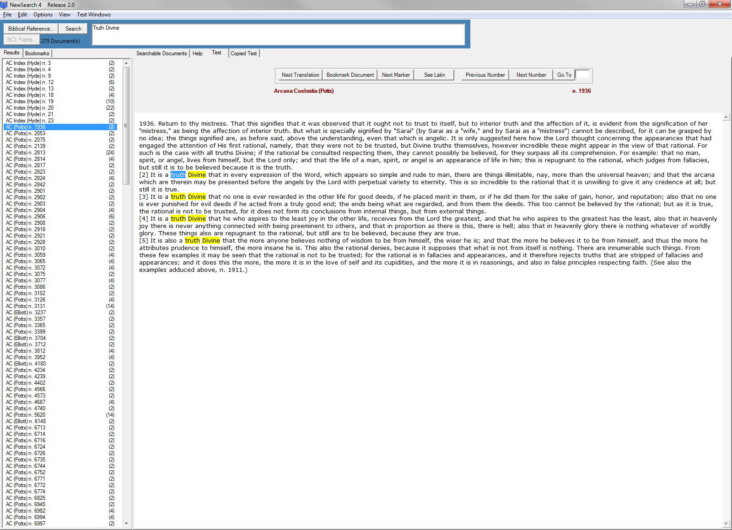
Figure 6 - Navigating the Retrieved Text

New Church Life Searching:

The New Church Life Collection covers all issues from 1881 through 2010. The searchable items are individual elements such as sermons, editorials, etc. This data base can be searched in the usual manner or by using a ‘field’ search (see below).

When ‘New Church Life’ is chosen as the desired data base from the pull down menu, you are given a list of years. The user can choose all years or any subset. When that choice is made, all filtering and displayed results will apply only to those years. The restriction to a subset of years, even though active, is not visible in the field box

Unlike the other databases in NewSearch 4, “The New Church Life” data base permits you to select:

- The type of document (Sermon, Article, etc)
- The Author
- The Title

You may select to enter information in one, two or all three of these categories. These choices act as a ‘filter’ on the database. Once the filter has been chosen, you may enter none or a collection of search words.

Here is an example: Suppose we want to check what sermons by Rt. Rev. Elmo Acton have the words ‘Divine Human’ in them.

We choose type = ‘sermon’, author = ‘Acton, Rev. Elmo C.’ Title is left at ‘ALL’ as seen in Figure 7:

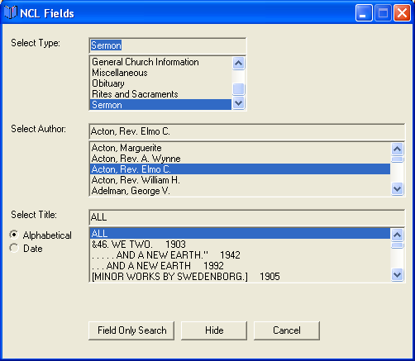

Figure 7 - Choosing NCL Fields

Then we enter “Divine Human” (no quotes) in the search box and select search. The result is four sermons, as seen in Figure 8:

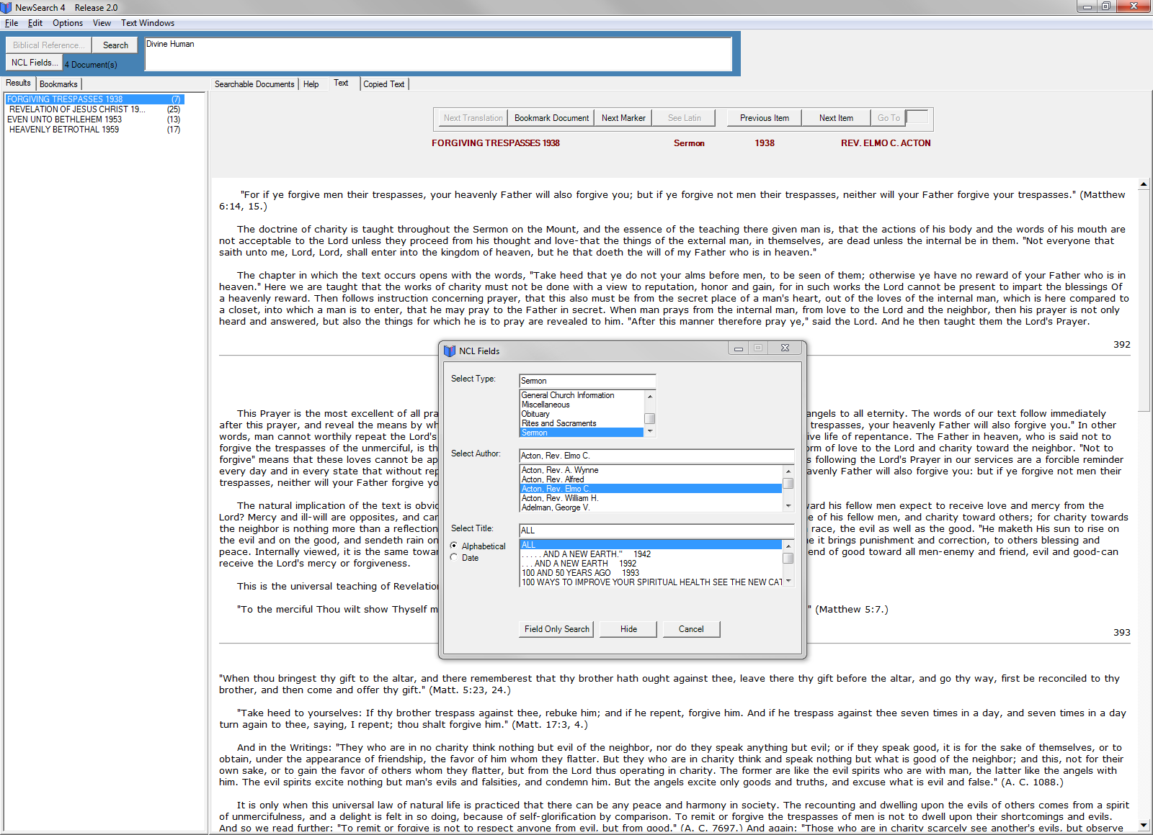

Figure 8 - Results of New Church Life Search

Now suppose we want all sermons by Rev Harold Cranch, but do not want to find sermons with specific words or phrase in them. We choose Author = “Cranch, Rev. Harold C.” and Type = sermons. Then select the button: “Field Only Search.” The result is shown in Figure 9:

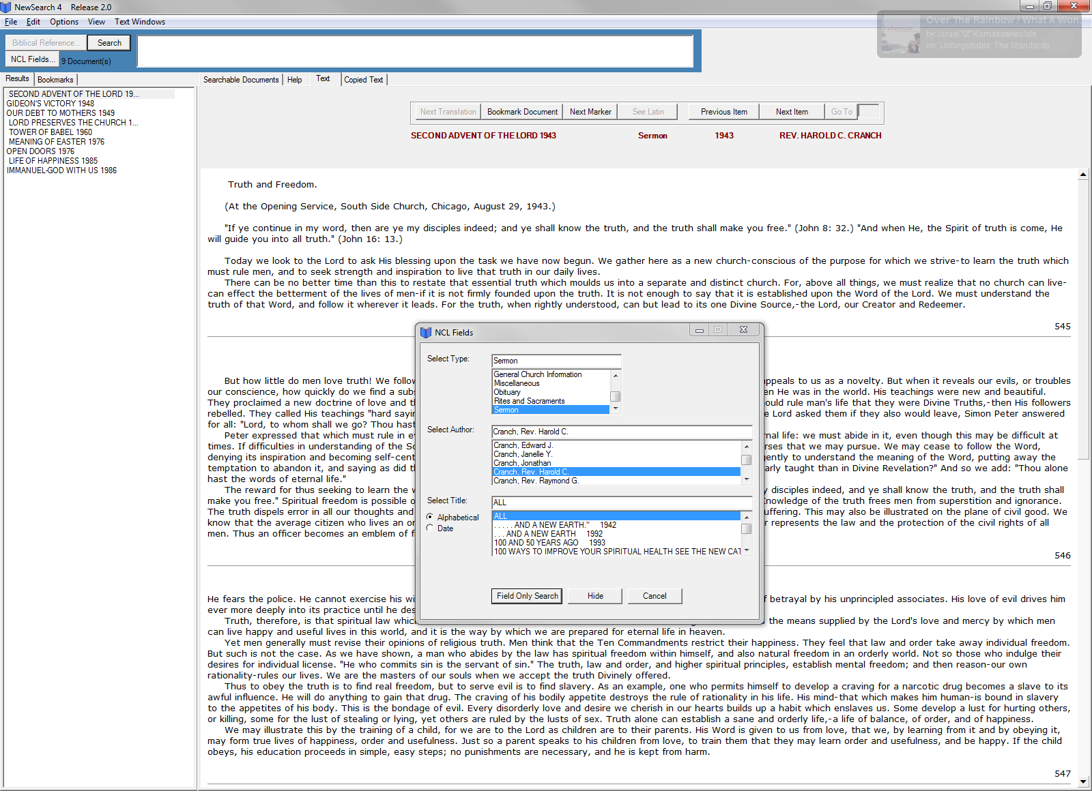

Figure 9 - An Example of New Church Life Field Searching

Using the ‘field’ choices. There are about 1,300 distinct authors. Finding them by scrolling may take time. However, if you start to type in a name, for example “Cran.” you quickly get to the section in which the name ‘Cranch, Rev. Harold C.’ is evident – you may have to scroll a bit. (See Figure 10.)

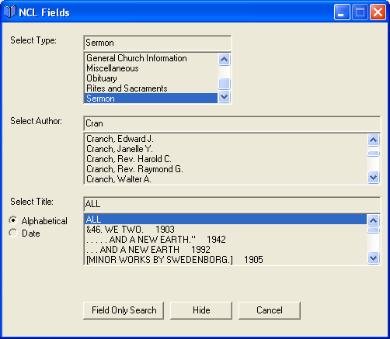

Figure 10 - Author Selection

The same thing is true for the other fields. Since there are 20,000+ titles this is very helpful.

Titles: The “Alphabetical” or “Date” choice on the left side of the window lists the items in the “Select Title” window in those two ways. You will see that there are some titles with no dates. We have eliminated the dates from repetitive titles such as ‘Editorial’.

Deselecting: If you want all items in a certain field, you must enter “ALL” at the top of that field.

Comments on author names. We have boiled all variants on an author’s name (for Elmo Acton, Acton, Rev. Elmo, Acton, Rt. Rev. Elmo C. , etc) down to a single standard name (Acton, Rev. Elmo C.) that appears in the in the list of authors. The name as it actually printed in “New Church Life” still appears when the text is displayed. There are still some errors in assigning standard names to the author names given in the text. We boiled all names of ministers down to Jones, Rev. Phillip W., even if Jones is a Right Reverend. For lay persons we eliminated all titles such as Dr. Esquire, etc. The rationale is that knowing that the author of an item in NCL is a minister could be germane, but the rest of the titles are not. Again this applies only to name in the “NCL Fields.” In the text the names appear as they were in the original.

Searching for titles: If you enter part of a title, the title box will scroll to the (first) title that contains that word or words. For example, if you enter ‘prayer’ in the title box (“ALL” in each of the others) and select search, you get 107 items. Some of those have the title “Prayer”. Others have titles such as “The Lord’s Prayer”. This gives greater breadth to the search.

DETAILED OPERATING INSTRUCTIONS

PULL DOWN MENUS

File - This section deals with printing, saving bookmarks and exiting the program.

Print Text – Allows direct printing of any active text window on your default printer.
Import Bookmarks - Lets you import any file of bookmarks you have saved. If there are currently any bookmarks in the bookmarks window they will be overwritten.
Export Bookmarks - Creates a file of the passage numbers contained in the Bookmark section. Choose a file and folder so you can save your bookmarks for future study or send them to another NewSearch4 user.
Exit - Quits the NewSearch4 program.

Edit - This section covers copying and saving text, movement within passages.

Copy - Copies any highlighted text to the clipboard for immediate pasting into a word processing document.
Select All - Selects and highlights the entire text shown in the ‘text’ tab.
Copy Selection to Copied Text… - Copies any highlighted text to the first tab area, whose– default name is “Copied Text.” If no text is highlighted, the whole passage is copied. Note: The search word is highlighted at first. (Use copied text options to indicate that you want the title or passage number to appear in the copied text)
Copy Selection To - This option also copies any highlighted text, but gives you a sub menu that allows you to select which tab to copy the text into. (See Options/Copied Text Options to set up multiple tabs.)
Find in Text - This opens a standard Windows text search box. It can be used for searching for words or phrases within the text already displayed. (Ctrl-F)
Find Next - Finds the next occurrence of the search word from the search just above.
Jump to Next Occurrence Marker – This jumps to the next occurrence of the target words in the chosen volume or to the next volume if you are on the last occurrence in the volume. (Ctrl-J)

Options - This section allows you to adjust the appearance of the text, set up tabbed files for copying, and set several other preferences.

Text Appearance - Brings up a window allowing you to choose the font, size, and color for the regular text, the targeted words, and the occurrence marker. You may also choose to have the targeted words highlighted. The first time you use Text Appearance you may have to choose a ‘type’ (font) for the other choices to work. (You may also activate this by a right click pop up menu when the cursor is in the text area) See Figure 11. When you change the appearance of the text, it will not show up until you go to another passage.
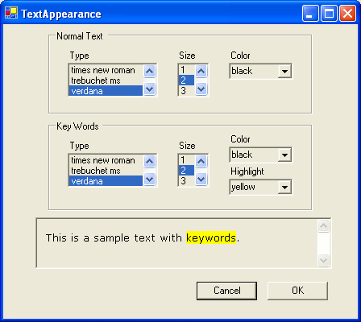

Figure 11 - Text Appearance

Copied Text Options - This window allows you to set up tabbed files for saving research by categories and to select where the files will be stored on your hard drive. See Figure 12.

Figure 2 Copied Text Options

This window also allows you to choose whether or not to include the full title of the work with the translator or just an abbreviation of it when text is copied. For example, material copied from passage number 162 in the Arcana Coelestia can be labeled either “Arcana Coelestia (Elliott) 162,” or “AC 162.” When the box – Use Full Book Titles When Copying is checked the full title is used. Otherwise the abbreviated title is used. See Figure 12.

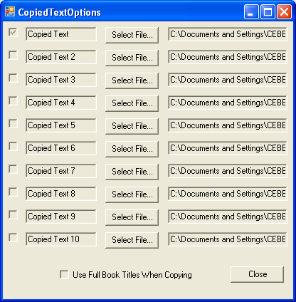

Figure 12 - Default setting for saving Text from tabbed areas

Using the box shown in Figure 12, you may change the default locations for saving the tabbed text or keep them as they are. For example if you want a tabbed area for Arcana Passages, you would check the box next to copied text 2, rename it ‘AC Passages’, and by hitting the “Select File” button, choose the folder and file name where it will be saved. It is actually saved when you click “Save Document” in the tabbed text area.

Once text has been saved to a tabbed file it can be copied to the clipboard or it can be saved to your hard drive.

Selecting the Copy Document to Clipboard places the text of that tabbed file on the clipboard, enabling you to then paste it into any word processing document.

In the “Copied Text” window, selecting the Save Document button saves whatever is in the file to your hard drive - onto the desktop or into the folder you have previously designated. Selecting the Save Document button overwrites whatever had been in the file with that title.
Warning: Text saved in a tabbed window is placed in the local memory only until you select the Save Document button. Until it is saved it is not a file on your hard drive and will be lost if there is a power or mechanical failure.

Text will be copied and saved in the rich text format. The rich text format works well because it will save and display any choices you make in font, font size, and color.

Material in tabbed files can be erased by manually highlighting and deleting text that is in them and then pressing the “Save Document” button. The material is also erased when the program is closed.

Preferences – This window allows various preferences to be set.

Automatically Jump to First Occurrence Marker, when checked, displays the text of the passage with the first occurrence of the targeted words visible. If not checked, the passage is displayed at its beginning.

Prompt Before Jumping To The Next Marker, when checked, brings up a window asking if you want to move to the next marker.

Confirm on Exiting the Program, when checked, brings up a window when exiting to confirm that is your intention.

Text Selection enable you to determine the color of the list of works displayed in the Searchable Documents window. The Big Font can increase the size of the font.

Background Image enables you to select the image or pattern that appears behind the list of documents in the document selection screen.

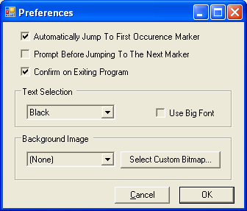

Figure 13 – Preferences

Note: You may add .bmp (picture) files to the folder: Program Files\STAIRS\debug\Custom Images. These will then be available by clicking the button “Select Custom Bitmap.” Or, you could select bitmaps from anywhere on your hard drive.

Frequently Used Books - Brings up a choice box to select books which you would like to appear at the top of the list when the data base of the Writings is displayed. When a book is checked, it moves to the top of the list on the main screen. Select one or more works and click OK as shown. You may deselect the books by using the same screen. This option is not available to New Church Life, New Church Translations, Journal of Education or the Theta Alpha Journal. See Figures 14 and 15.

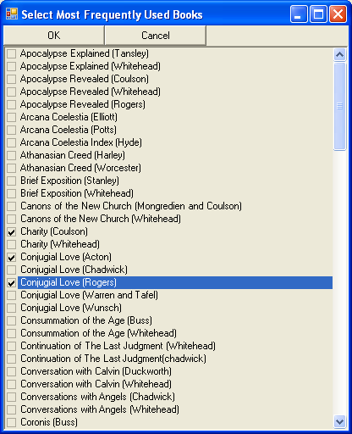

Figure 14 - Choosing the Most Frequently Used Books

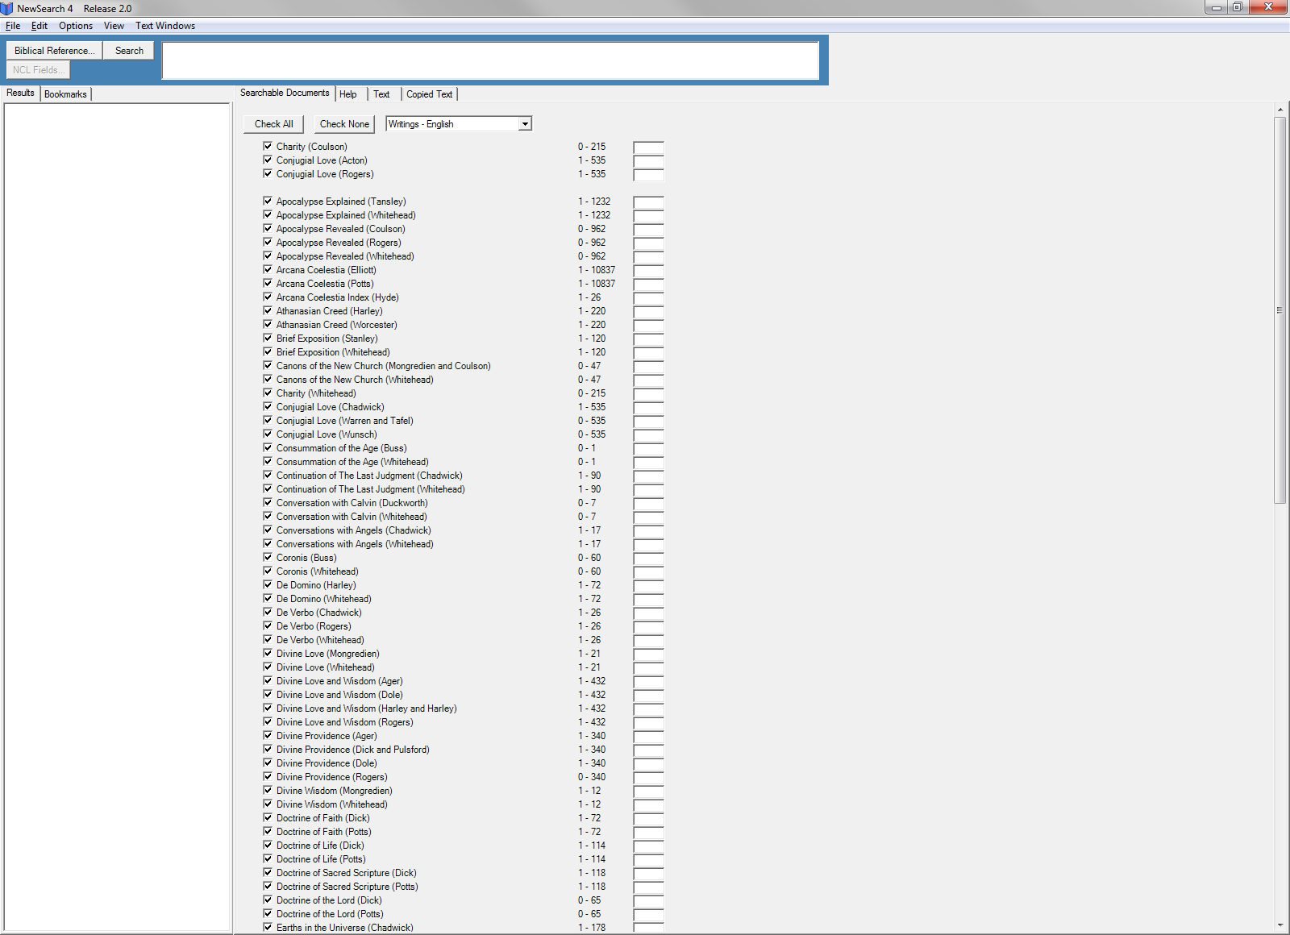

Figure 15 - The chosen volumes appear at the top of the list

Document Selection Sort Order: This allows you to choose the display order of the books in the data bases. Different choices are offered – as appropriate – for each of the 8 collections. For sorting the results window (the left window), see below - Search Results Sort Order.

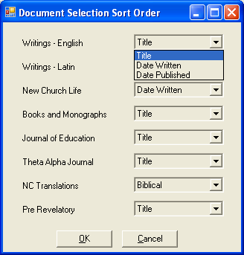

Figure 16 - Choosing the Order of Display for Document Selection

Figure 16 shows the choices for the English Writings. If you try the pulldowns, you will see the available choices for the other collections.

Search Results Sort Order: - Displays a list of result sort orders for each database. This allows you to order the results (left window) list according to the chosen criterion. An example is shown for New Church Life in Figure 17.

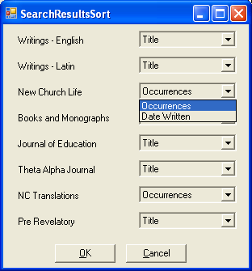

Figure 17 - Choosing the Order for the Results Display

Note: If you change the results sort order after a search, you must rerun the search to get the new order.

View - This window provides you with two choices: search history and notes.

Search History - This selection gives you a list of the searches you have so far done during this session with the program. Selecting the item reenters its search criteria in the search area.

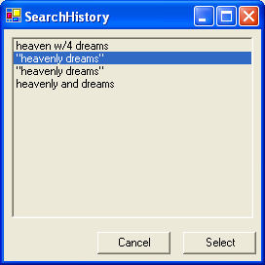
Figure 18 - Search History

Notes - This option allows the user to make notes on each passage or document. When you enter a comment and select Save Notes, it is stored. When you access that document again and select Notes, the comments appear. You can edit them at any time the passage is active.

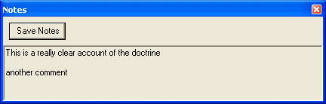

Figure 19 - Notes

Text Windows - This option allow you to create windows of the current search text. Multiple windows for different passages can be created. The windows can then be tiled for comparison or viewed by a pull down list. The options in the menu are self-explanatory.
Hint: A right click on the mouse when you are in the text window produces a pull down menu that allows choices for text appearance, text windows and notes.

Button: “Biblical Reference” – this allows access to Searle’s Index of passages where Scripture is quoted or referenced in the English Writings.

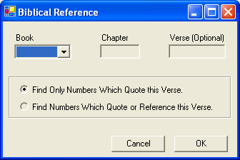

Figure 20 - Biblical Reference Window

Biblical References – Searle’s Index

Explanations in the Writings of verses from the Old and New Testaments can be found using the General Index to Swedenborg’s Scripture Quotations by Arthur Hodson Searle (usually referred to as Searle’s Index. Select the Biblical Reference button. The Select Book, Chapter and Verse(s) window enables you to enter a book and a chapter number for searching. It is not necessary to enter a specific verse. You may use a range of verses, for example Matt 6 19-21.

Once “OK” is selected, it places the search request in the Search Window. At his point you may add other search terms. For example, when you select Matt 6:19 you get 5 results. When you add “stealing” the search looks like <Matt 6: 19> and stealing, you will get only one passage. Now click Search or hit the return key to display the list of passages in the Writings which quote or use the verse(s). You may enter the Searle’s search directly into the search window by typing <Matt 6:19>.
Searle’s index will take you to the relevant subsection. That will be highlighted in the text window.

The option to Find Only Numbers Which Quote this Verse, or Find Numbers Which Quote or Reference this Verse, represents a distinction found in Searle’s Index. Searle identifies passages that directly quote a verse from the Old or New Testament by placing it in boldface. To capture all passages which contain the desired chapter and verse, whether directly quoted or not, select the second option: Quoted or referenced option.

Wildcard and Boolean Searches – Please see the NS4 help in the help tab.

SEARCH RESULTS WINDOW

The window on the left-hand side of the screen displays a list of all the documents that contain the search words or criteria. The number in brackets to the right indicates how often the searched for word appears in the document. A document is any passage, page or article of text that will be displayed that has the search results. For example, in the Writings, a document is a passage. In New Church Translations it is a chapter of Sacred Scripture. For New Church Life it is an article or sermon and similarly for the other collections.

The size of the search results window and the document selection window can be changed by putting your cursor on the edge of the window and dragging it right or left, a standard Windows function.

There are two tabs at the top of the Search Results Widow, “Results” and “Bookmarks.” Bookmarks are for recalling previously bookmarked passages.

TEXT WINDOW

When you click a result in the Results window, the text appears – with the search words highlighted – in the right window that was previously occupied by the document selection panel. These panels are controlled by the tabs (“Searchable Documents”, “Help”, “Text” and “Copied Text”) that appear at the top of this window.

The text window has seven buttons which are: “Next Translation”, “Bookmark”, “Next Marker”, “See Latin”, Previous Number (page)”, “Next number (page)”, “Go To”. Depending on the databases, these buttons will be grayed out or have names changed (such as page for number) as appropriate. Next Page or Number means next document in whatever collection you are using.

- Next Translation – only applies to the English Writings, enabling you to see the same passage from different translators. Hint: If you highlight a portion of text, when you go to the next translation you will see the highlighting in a place that is located a similar distance through the passage. This is not an exact correlation between passages, but a rough approximation so you might be close to the same portion of the text. This also works for “See Latin.”
- Bookmark – pressing this will store a reference to the text being viewed. You may retrieve it by going to the Bookmarks tab in the results window. When you click that tab, you see a list of all the references you have saved. These are kept between uses of NewSearch4.
- Next Marker – takes you to the next occurrence of the search target. In most cases these are highlighted, but not in the case of Searle’s references. If you run out of targets in one document, it takes you to the next document. This button has the same effect as using Ctrl-J or using the pull down Edit | Jump to Next Occurrence.
- See Latin – enables you to see the underlying Latin of the English passage of the Writings you are viewing.
- Previous Number (page) – this takes you to the previous document in the particular work. It has nothing to do with the occurrence of the search targets. It is just a convenient way to navigate around in context.
- Next Number (page) – Previous Number (page). This is the same function except moving forward to the next passage or page in the work.
- Go To. Put a number (page or passage) in the box and click to jump to that page or passage.

PRINTING TEXT

Text, either in the Text window or in any of the tabbed text folders, can be sent directly to your printer. When this is done, the entire passage or saved text in tabbed folders is printed. To do this, place the cursor anywhere in the text and either select File, then Print Text, or use the “control” and “p” key commands.

DISCUSSION OF SACRED AND COLLATERAL TEXTS

DATA BASES: WRITINGS – LATIN

The General Church Translation Committee has provided the Latin texts. These are used with permission. The committee funded the scanning of it and is still in process of editing it. So far the works published by Swedenborg himself have been thoroughly edited, but those published after his death are still in the process of being more closely edited.

Editing the Latin text is very challenging work. There are several reasons for it. First, any editing work requires extensive knowledge not just of Latin, but also of the small sub-field of Neo-Latin. This Latin has received little scholarly attention and so there are virtually no grammars or dictionaries extant. Second, Swedenborg used hundreds of unique Latin forms not found elsewhere. It would be easy for a non-expert to assume that there is an error in the text when it was simply a unique form employed by Swedenborg. Third, many of the Latin texts are not perfect. Printers occasionally misread Swedenborg’s handwriting and introduced errors in the original printed versions. Printers also were prone to use their own spelling, regardless of what the author wrote. And finally, many of the manuscripts, such as Apocalypse Explained, were produced quickly to make it available and have never had a critical Latin edition produced.

However, in the last twenty years new critical versions have been prepared for:

- Apocalypse Revealed
- Conjugial Love
- Divine Love and Wisdom
- Divine Providence
- Spiritual Experiences
- True Christian Religion

We received these in electronic form, so they should have a high degree of accuracy.

There are also works for which there is no electronic version available. These are:

- Gad and Asher
- Index to the Formula Concordiae
- True Christian Religion Additions
- Miracles and Signs
- Marriage Indices
- Summary Exposition of the Apocalypse
- Consummation of the Age
- Letters

If, in using the Latin text, you uncover what you think to be an error, please send it to the STAIRS project. Such potential errors will be communicated to the General Church Translation Committee for examination.

Spiritual Experiences

The Latin text is taken from the new Latin edition, Dr. Durban Odhner, editor, 1991. This work was not published by Swedenborg, and he used it almost as a notebook at times. Thus it has various marginal notations, Swedenborg’s emendations, passages crossed out in various directions, and a few roughly drawn maps. These elements cannot be exactly replicated in NewSearch, but are noted in footnotes.

DATA BASES: NEW CHURCH LIFE

New Church Life is a “monthly magazine devoted to the teachings revealed through Emanuel Swedenborg.” It is published by the General Church of the New Jerusalem and became its official journal when the church was organized in the late 1800s. It contains sermons, scholarly studies, news about events in the General Church, reports from the office holders of the organization, and keeps the official records of baptisms, marriages, deaths, etc.

Much of this periodical was scanned with early OCR software, and is likely to have a higher error rate than other data bases.

DATA BASES: BOOKS AND MONOGRAPHS

This collection of New Church collateral literature spans a wide range of topics – from Biblical interpretation, doctrinal studies, to histories and biographies. Emphasis was placed on scanning works which are no longer in print. This was both to make them available to future generations, and also because there were no issues with copyrights. Some more recent works are included, for which we have obtained copyright permission.

The documents are usually divided into page numbers. Where page numbers were not useful divisions, but the document was too long be shown as one number, we numbered sections within the document.

DATA BASES: JOURNAL OF EDUCATION

The Journal of Education, later re-titled Academy Journal, contains extensive information regarding the Academy of the New Church – minutes of the corporation meetings, reports of the school heads, catalog of courses, articles on New Church education, a list of graduates, etc.

DATA BASES: THETA ALPHA JOURNAL

Theta Alpha Journal is official journal of the Theta Alpha – Daughters of the Academy. Founded in 1904 for the furtherance of New Church education and comprised of women members of the General Church, it began publishing this journal in 1910. It contains a wide variety of material supportive of education and of interest to their membership.

DATA BASES: NEW CHURCH TRANSLATIONS

The goal of a translation of the Old and New Testaments by a New Church scholar or scholars has long been held and never fully realized. Individuals have developed translations of some of the books, often in conjunction with translations of the Writings or in various commentaries on the Sacred Scripture.

The translations of Genesis through Deuteronomy are from the Pentateuch. It was translated directly from the original Hebrew by Norman Ryder with support from Dennis Duckworth and Herbert Mongredien, and published by the General Conference of the New Church in 1970. The translations of the Gospels and the book of Revelation are from the Sacred Scripture or the Word of the Lord: New Testament, edited by Stephen Cole and Andrew Heilman in 2002. The Gospels were originally translated from the Greek by John Clowes in his commentaries on the Gospels from 1805. The translation of the book of Revelation is based on John Whitehead’s translation of Apocalypse Revealed from the early 1900s.

DATA BASES: PRE-REVELATORY

Emanuel Swedenborg was a well known 18th century natural scientist and philosopher long before he began writing works about theology. These works are here termed “pre-revelatory” as they predate his phase of Divine revelation. Some were published by Swedenborg while others were found unpublished among his manuscripts after his death. (See Appendix G for a complete list.)

Swedenborg numbered his paragraphs in some of these works, but not others. Where they are numbered, we have used that system. Where works were not numbered we have introduced numbers so that documents which appear on the screen are not overly long. These numbers were either page numbers from the printed works or sections within the work.

SOURCES OF THE TEXT OF THE WRITINGS

The text of NewSearch 4 comes from books published by several organizations:

The Academy of the New Church
The General Church of the New Jerusalem
The Swedenborg Foundation
The Swedenborg Scientific Association
The Swedenborg Society

Most of the texts are copyright protected. Where a copyright exists, we have obtained permission to use the texts in NewSearch 4. The “fair use doctrine” of the United States copyright law states that quotations may be taken from them for personal use, scholarship, teaching, research, or comment and review purposes only.

Most of these translations are in print and can be purchased in book form from the following:

General Church Book Center
Box 277 C
Bryn Athyn, Pa. 19009
Tel: 267-502-4922
Email: bookstore@newchurch.org

Books may also be ordered directly through the on-line bookstore at:

www.newchurch.org

Publishing houses to contact directly for purchase or questions regarding their publications:

General Church Publication Committee
C/o The Rev. Grant Odhner
Box 717
Bryn Athyn, Pa. 19009

Swedenborg Foundation
320 N. Church Street
West Chester, Pa. 19381-0549
Tel: 800-355-3222
www.swedenborg.com/

Swedenborg Scientific Association
Box 757
Bryn Athyn, Pa. 19009
www.newphilosophyonline.org/

Swedenborg Society
Swedenborg House
20-21 Bloomsbury Way
London, England WC1A 2TH
Tel: 011-44-171-403-7986
www.swedenborg@org.uk/

Accuracy of the Text

Every effort has been made to reproduce the printed versions accurately. However, two factors make the texts less than perfect – the required format by the search engine and the quality of scanning printed works or errors in electronic text transmission.

The “plain text” format that NewSearch requires has limitations. It does not allow many font options. Thus italicized print, bold faced print, or text font sizes and styles in the original are lost in the NewSearch text. Moreover, occasional marginal notes, maps, photographs, diagrams, and tables cannot be accurately reproduced in this format. (These are portrayed in footnotes.)

Works that are scanned from printed texts are prone to error. This is due either to the quality of the printed texts or the quality of the scanning equipment and software. The texts have been scanned starting in the 1980s, when software was comparatively primitive.

A few of the more recently printed works were obtained in electronic form. But we have found transferring the data from one word processor or computer to another has also occasionally introduced errors.

Some of the text, primarily the Writings, has had extensive editing to correct errors. But some of the other date bases, including New Church Life, has had very little editing and we would expect a higher level of error rate there.

Any errors found in the text of NewSearch should be communicated to the STAIRS project: brian.keith@newchurch.org. These will be corrected in future releases.

Re-named Works

We have retained the original titles of all works from their printed forms. However, in the text of the Writings there are two exceptions to this – works where translators have selected different titles for the identical work, and in cases where recent scholarship has indicated a change.

Where there are multiple translations of a work but which translators have given varying names, we have retained the standard names so they appear next to each other on the list. This occurred with Chadwick renaming Earths in the Universe as Worlds in Space and Rose renaming True Christian Religion as True Christianity.

There are several other cases where previously standard titles have been changed. Spiritual Experiences used to be known as the Spiritual Diary. Dr. Durban Odhner, in his translator’s Preface to the first volume makes a convincing case that “diary” is not an appropriate title and that Swedenborg thought of these notes as “experiences.” The work previously known as The Intercourse of the Soul and Body has been altered to The Interaction of the Soul and Body. Since the word “intercourse” today is used almost exclusively with sexual connotations, which is not the meaning in the original work, this change has been made in the titles and all cross references to it in the text of the Writings. Abomination of Desolation is another title for The Consummation of the Age, under which it is listed. The small work entitled On the Natural and Spiritual Sense is actually found within the text of Swedenborg’s letter to Oetinger, Oct. 23, 1766. In NewSearch it is found there and has no separate listing. The work entitled Influx is a small fragment found on the fly-leaf of Swedenborg’s copy of Swammerdam’s Biblia Naturae. It does not refer to The Interaction Between the Soul and the Body, which it had sometimes been called in the past.

Footnotes

In the text of the Writings, all footnotes denoted by an asterisk (*) are the work of the various translators and editors. Footnotes denoted with a number sign (#) and not with an asterisk are written by Swedenborg himself. These are found in seven works: Heaven and Hell, Last Judgment, Earths in the Universe, On the Divine Love, On the Divine Wisdom, Doctrine of Life, and Doctrine of the Lord. When Swedenborg’s marginal notes are inserted as footnotes, an asterisk is usually employed with quotation marks to indicate original text.

When there are multiple footnotes in any passage from the Writings, the number of asterisks enables you to connect the text with the appropriate footnote. Thus the third footnote in a passage will have three asterisks, as will its footnote in the passage. In other works, such as New Church Life or New Church collateral works, footnotes have been connected to the paragraph in which they belong, rather than at the bottom of the page as is done in printed works.

Display of Books of the Writings

The large window on the right-hand side displays a complete list of the Writings with the translator’s name in parentheses. Each work is listed separately rather than grouping smaller works together, such as has been done in The Four Doctrines or Miscellaneous Theological Works. While this makes for a very long list, it respects the individually of each work and enables you to select or deselect any desired work for searching purposes.

The works can be displayed in alphabetical order (by title), or by the date when they were written or published. See the Document Selection Sort Order under Options.

Individual works can be moved the top of the list by selecting Frequently Used Books in the menu under Options. Selected works, retaining their alphabetical order, are then placed at the top of the list with a line separating them from the rest of the works. However, this does not change the order in which the passages containing searched for words and phrases appear in the left-hand window.

Individual works can be selected or deselected by clicking on the box to the left of the title of the work. The default position is to have all these works selected so searches will display all occasions when the word or phrase is found in them. When individual books are deselected the program will still search them, but only the selected books will have their numbers displayed in the Search Results window, available for looking up individual passage numbers.

Individual passages can be found by entering the passage number in the box to the right of the book title and selecting Search or the Return key on your keyboard. The range of passage numbers is located immediately following the title of the work.

Brackets and Parentheses in the Text of the Writings

In general, any words or phrases in brackets [ ] are added by the translator and any words or phrases in parenthesis ( ) were written by Swedenborg. There are two primary exceptions to this. The first is passage numbers added by translators. Occasionally Swedenborg did not number his paragraphs. When translators or editors have added them to the text they usually have brackets around them to indicate that. However, for simplicity in the program we ignore the distinction. Thus works unnumbered by Swedenborg for which translators have inserted numbers, such as in Canons, Athanasian Creed, On the Divine Love, and On the Divine Wisdom do not have brackets to indicate an addition to the text. The second exception is found in Spiritual Experiences. The multiple parentheses surrounding passages in the printed text are the addition by translators to indicate that Swedenborg put lines through the text, as if crossing it off. It is believed that that this was Swedenborg’s notation system to indicate when he had used material from a passage in a later work.

Repeated Numbers in the Writings

Throughout the Writings, Swedenborg occasionally repeats numbers, or, rather, uses the same number for two sequential paragraphs of text. Usually this involves only one number, such as AC 10249-10250, but on some occasions a series of numbers are repeated, such as CL 151-156, and once a large section is repeated, SE 4545-4791. When a single passage or a few passage numbers are repeated, only the first passage number is referenced in NewSearch. For example, Conjugial Love 444 is used for both the memorable relation at the end of a chapter and the first number of the next chapter. A direct search for CL 444 will place the cursor at the beginning of the memorable relation. The beginning of the next chapter is found further down in the text.

While this occasionally results in a large amount text to scroll through, it removes the necessity of knowing whether a passage is repeated or not, and then whether the translator has labeled it with an “a,” “1/2,” or “bis,” in order to find it. Citing passages in articles should still include the specific number with its means of designating that it is repeated. Thus the internal sense of “And thou shalt put it between the Tent of meeting and the altar” is found in AC 10237a, not AC 10237.

Canon?

The data base of the Writings NewSearch is not intended as a statement about the canon of the Writings – that is, works which everyone agrees are Divine revelation as opposed to works by Swedenborg everyone agrees are not Divine revelation.

There is no formally agreed upon canon in the New Church for the Writings. There is general agreement that works published by Swedenborg himself of a theological nature after his spiritual eyes were opened should be included in any canon. And most would also include theological works that Swedenborg wrote after his spiritual eyes were opened, but which he himself did not publish. (They were preserved and published after his death.) However, material written in the transition phase as his spiritual eyes were being opened and as he was first exploring the spiritual world, such as the early portion of Spiritual Experiences, have sparked debate in the past and are likely to do so in the future.

It is a testament to the freedom of thought in the New Church that no canon has ever been established, but that individuals are encouraged to explore and reach their own conclusions. In keeping with this spirit, NewSearch has attempted to cast a wide net and include as much material as possible that could be considered by anyone as belonging to Divine revelation.

COMMENTS ON INDIVIDUAL WORKS

Arcana Coelestia

Most of the Elliott translation, numbers 1-9111, was scanned and edited. The 11th and 12th volumes were provided in electronic form. However, footnotes had to be connected with the proper place in the text. All errata which has been noted in the back of these volumes have been corrected in the NewSearch text.

One additional emendation has been made at the request of the translator, the Rev. John Elliott. We have changed the pronouns referring to the Lord in the first volume, numbers 1-1113, from “Thee” and “Thou” to “You.” This brings the first volume into harmony with the rest of his translation.

There is a discrepancy in the numbering system between the Potts and Elliott translation of numbers 10249 and 10250. This is due to an unnumbered paragraph that is given an “a” designation – i.e. there are three paragraphs with only two numbers used and one is repeated. The Potts sequence is 10249, 10250, 10250a. The Elliott sequence, following the new third Latin edition, is 10249, 10249a, 10250. Thus the last two paragraphs in the sequence have different numbers.

To enable the Next Translation function to find the same material, it was necessary to make these two systems agree. Since Elliott’s translation is based on more recent and complete research, we have changed the Potts’ numbering system. Thus previous references to AC 10250 in the Potts translation can now be found in AC 10249 in both translations.

Apocalypse Explained

The lengthy numbers of Apocalypse Explained are divided into the subsections originally employed by Potts in the Swedenborg Concordance. The previous system of identifying subsections by letters, introduced by Dr. Worcester, has been removed. This has been done for two reasons. The first is that this sub-referencing system is rarely, if ever, used. The second is that this eliminates confusion when one seeks to look up a number directly in NewSearch. Thus you may enter the number 278 to go directly there and you will not need to know that Worcester numbered it 278a.

English translators have noted the absence of any explanation for the final sentence of Chapter 12, verse 15. Whitehead’s translation draws a brief internal sense from the beginning of that chapter and numbers it 763 1/2. The passage numbered 764 then begins at verse 16 and the number 765 is not employed in the translation. Careful research by the Rev. Stephen D. Cole has uncovered the missing passage. It is numbered 764 in NewSearch and what had typically been numbered as 764 in English translations has been changed to 765. See the footnote at 764 for a more detailed explanation provided by the Rev. Cole.

In the Tansley translation, beginning in the third volume at number 415, there were three changes in the style of presentation of the printed text. These are not discussed in the translator’s notes. First, cross-references to previous passages now include subsections. Since subsections were created by Potts and are not in the Latin text, these subsectioned cross-references must have been added by Tansley. However, this is not indicated by the use of brackets by the translator. Second, some bracketed letters were placed in the margins. These appear to be a previous method of subsectioning the longer numbers. They have been removed as they were from the Whitehead translation. And third, the format of the text is condensed. Quotations from Scripture are no longer set apart with double hard returns. Because this makes the text more difficult to read, especially on a computer screen, we have maintained the style from the previous two volumes throughout this work.

The Athanasian Creed

This text does not originally contain any passage numbers. However, paragraph numbers have been added which Potts employed in his Swedenborg Concordance.

Canons

The passage numbering system has been added to the text.

Conjugial Love

Translators have treated the repeated passage numbers differently, as is most evident in numbers 151-156. This sequence of numbers is repeated immediately after itself. Thus the sequence of passages is numbered: 151, 152, 153, 154, 155, 156, 151, 152, 153, 154, 155, 156. Acton repeats 156 and attaches a sequential letter to it. Thus his numbering of the repeated numbers reads: 151, 152, 153, 154, 155, 156, 156a, 156b, 156c, 156d, 156e, 156f. Rogers and Wunsch repeat the series of numbers, but add “r” to each repeated number – an abbreviation for “repeated.” This series reads: 151, 152, 153, 154, 155, 156, 151r, 152r, 153r, 154r, 155r, 156r. Chadwick follows this pattern, but adds “bis” to each - the Latin word for “twice.” His series reads: 151, 152, 153, 154, 155, 156, 151bis, 152bis, 153bis, 154bis, 155bis, 156bis.

Because few would recall how each translator treats these repeated numbers, the text of all of them is included in the passage numbered 156. This makes for a very long passage, but it seemed the least confusing way to give access to the text.

De Verbo

This work is one of the posthumous works for which Swedenborg did not provide Arabic paragraph numbers (1, 2, 3…). However, he did number sections using Roman numerals (I, II, III…). Rogers, in his Translator’s Remarks to Three Short Works, makes a strong case for using these numerals rather than introducing an additional numbering scheme. Accordingly, we have used the numerals supplied by Swedenborg himself, but employed Arabic numerals in addition to the Roman numerals.

Earths in the Universe

The new translation by John Chadwick was entitled Worlds in Space. We altered the title so that it may be found next to the other translations of this work. No other changes were necessary within the text itself.

God the Savior

Harmonizing Dr. Whitehead’s and the Rev. Duckworth’s translations of God the Savior, required some adjustments. The British spelling of “Saviour” could not be used in the title so the Next Translation function will operate. However, it was retained throughout the rest of the work. Duckworth rearranged the material itself. No explanation is given in his preface. Neither did Duckworth give any numbers to the material. We have included the numbers added by Whitehead. But we have retained the order of material that Duckworth presents, assuming it is more accurate scholarship. Thus the material in Whitehead’s translation was rearranged to agree with Duckworth’s. A number-by-sequential-number search through Whitehead’s translation will reveal this order: 0, 14-48, 1-13. This does not adversely affect comparing numbers between the two translations.

Justification

The numbering of this work presents some challenges. It has three distinct sections. It begins with very brief unnumbered or undesignated preliminary notes. Duckworth notes, “Most of these preliminary notes became the titles of sections in the material that follows.” Then follows a short section with each individual paragraph having an Arabic numeral, numbers 1-9. Finally, there is the largest section that is divided into Roman numerals (I-IX). The translations by Whitehead and, more recently, by Duckworth have two different numbering schemes to deal with this dual system employed by Swedenborg.

Whitehead does not have the initial very brief section in his translation. He uses the Arabic numbers for the second section and extends them through the third section. However, in the third section he does not connect the numbering system he introduces to the Roman numeral system already present. Thus, within the 9 Roman numeral sections he uses 48 Arabic numerals – the number of individual paragraphs contained within the 9 Roman numeral sections – producing a range of numbers from 1-55. The Roman numerals are present in the text; however, it is presumed they should be ignored for citing material from this section.

Duckworth does not attempt a universal numbering system within the work and leaves the three sections appearing as they do in Latin – the first unnumbered, the second with Arabic numerals, and the third with Roman numerals. He separates them by brief editorial comments.

While Duckworth’s scheme is a more accurate depiction of the Latin, it presents problems for an electronic search program such as NewSearch that requires a universal numbering system. Also, to use the Next Translation feature that allows users to compare translations in NewSearch, the numbering systems must be identical. One, or the other, or both of these numbering systems had to be altered for this program.

Because we cannot use Duckworth’s system, and because Whitehead’s system unnecessarily creates numbers for the largest section, we have decided to re-number the work in the least disruptive way. The very brief preliminary material has been given the designation of “0.” The second section uses numbers 1-9 as they appear in the Latin text. In the third section we have continued the Arabic numbering in sequence, but placed them where the Roman numerals are. (I.e., Roman numeral section IV is now paragraph number 13.) This follows the principle elucidated in the Rogers’ translation of De Verbo of reflecting Swedenborg’s own numbering systems as closely as possible. The Roman numeral sections are not overly long, so this should present no problem when citing this work. This produces a range of 0-18, rather than 1-55, as in the Whitehead translation. Whitehead’s numbers are included in both texts in bracketed numbers so earlier citations to this work can be found.

Last Judgment Posthumous

Recent scholarship by the Rev. N. Bruce Rogers shows that the material of Last Judgment Posthumous became mixed up in the collection of various unpublished manuscripts. In his “Translator’s Remarks” to Three Short Works an explanation is given for this. The Rogers’ translation thus has an entirely different numbering sequence than Whitehead’s previous translation.

Unfortunately, for NewSearch to be able to find and display the same passage between these two translations, the numbering schemes must agree. In light of Rogers’ scholarship, the material in the Whitehead translation has been rearranged and re-numbered so that it is identical to the Rogers’ translation. The original numbers are retained within brackets in both translations. A printed table of equivalency can be found in Appendix C.

Also included in the Rogers’ translation is a corrected footnote at passage 103 regarding the Bull Unigenitus. This correction was made by Rogers after Three Short Works was published.

Letters

The collected letters of Swedenborg are taken from three sources: Dr. R. L. Tafel’s Documents Concerning the Life and Character of Emanuel Swedenborg, Dr. A. Acton’s translation in Letters and Memorials, and from Doris Harley’s translation in The Small Theological Works and Letters. These collections contain many of the same letters, but also include other letters unique to each work. So occasionally there will be no other translation available for one or more of these letters.

The letters are placed in the order in which they were written and each is given a number for facilitating searching and retrieving information. In citing letters the numbers should not be used, but the traditional form retained, such as: Letter to Beyer, Nov. 14, 1769.

Marriage Indices

The first and second Marriage Indices have no inherent numbering system. Due to the length of these works, and, again, the need for paragraph numbers for the search program, we have introduced them. Paragraph numbers are inserted at the beginning of each new word in the index. These should not be used in citing the work. See Appendix D for a complete list of the words and the numbers associated with them.

Nine Questions

These questions posed by Thomas Hartley, one of the earliest adherents to the New Church, and Swedenborg’s answers, are traditionally presented as a separate work. While they can rightfully be classified as a letter, they are so well known by the title of Nine Questions that we have left them in this form.

Passage numbers have been supplied according to the numbering of the questions.

On the Divine Love and On the Divine Wisdom

The numbering system for these two works is unique to NewSearch. We did not want to create a new system, but previous referencing schemes would not work with NewSearch.

Each section of text identified by a Roman numeral (I, VI, IX, etc.) has been given a number. In addition, the sub-points in the original text of On the Divine Wisdom have been given a subsection number in brackets. This creates an easy and logical numbering sequence with the exception of number 11 in On the Divine Wisdom. Because that section has two sets of sub-points, the second set had to be given the next sequential set of numbers. Thus the second set of sub-points, numbered 1-8, has subsection numbers of 9-16.

In the text of On the Divine Love we have also included the subsections of Whitehead’s translation in brackets, since there is no conflict due to there being no sub-points in this work. In the text of On the Divine Wisdom, the subsections of Whitehead’s translation are included in double brackets. Subsections with single brackets in this work align with Swedenborg’s sub-points. And in Mongredien’s translation we have retained his numbering system in single brackets.

Swedenborg did not provide paragraph numbers. He did provide Roman numerals for large sections of text and Arabic numerals (1, 2, 3,…) for sub-points in On the Divine Wisdom. On the Divine Love employs section numbers I-XXI, and On the Divine Wisdom employs section numbers of I-XII.

Whitehead’s translation uses the Roman numerals for section headings. Subsections with Arabic numerals, encased in brackets, were added. However, these subsections bear little relation to the sub-points Swedenborg inserted in the original text of On the Divine Wisdom.

Mongredien’s translation has merged these two works together as if they were one, and has introduced a numbering system that is sequential through them both. (i.e. number 85 is actually section V in the second work, On the Divine Wisdom.)

While we were averse to creating yet another numbering system these two previous systems either would not work in our format or did not seem to faithfully represent the organization of the material. Because NewSearch requires paragraph numbers for searching and we think it important to maintain the distinction between these works, there seemed to be no alternative. As in De Verbo, this system of numbering comes closest to respecting the original organization of the material.

Prophets and Psalms

The structure of Prophets and Psalms, with two sets of subjects related to most verses - a particular statement of the internal sense next to the verse and a number indicating the general topic - is very difficult to portray in a computerized search program. The numbers placed at the end of each verse indicates the general subjects. These refer to the Table of Subjects found in the beginning of the work. In NewSearch this table is found at passage 0. It is also found in printed form at the end of this manual in Appendix E. The numbers in the text that refer to it are found at the end of the statements of doctrine associated with the verses. Thus for example, Jeremiah 12 is found at number 78. Appendix F has a list of passage numbers associated with Biblical references. These have been added to the text for the search program and should not be used when citing this work.

Scriptural Confirmations

As this is a list of passages from Scripture under various headings, it contained no passage numbering system. We have introduced a numbering system to make logical breaks in the text. These should not be used in citing the work.

Spiritual Experiences

Spiritual Experiences has previously been known as the Spiritual Diary. When it was given this title there was no evidence that Swedenborg had provided one. Recent scholarship has found that he did consider it to be his spiritual experiences, and hence the new and proper title. (See Dr. Odhner’s translator’s remarks in the first volume of Spiritual Experiences for further details.)

The Buss translation is actually the work of four translators –
1-1538 - A. W. Acton
1539-4544 - George Bush and John Smithson
4545-5659 - George Bush and James F. Buss
5660-6110 - James F. Buss
SE Minor - James F. Buss

This has produced some stylistic and formatting variety within the work. We have attempted to bring many of the formatting differences into harmony. We have also used Buss’ name for the sake of convenience.

Translators use different approaches to indicating words which the translators have added to the text for clarification. Since Spiritual Experiences had numerous translators, the formatting is not consistent throughout. Both parentheses and brackets were used to indicate editorial additions.

We have attempted to make this consistent by changing the parentheses to brackets where there are clearly words added by the translator. Often this is seen where the translator provides an alternative rendering. For example we find: “and bonds [restraints] [vinculum],” (2321) “a crowd [confusion] of spirits,” (2342), and “distances from [by] intermediates” (2333).

The addition of the new Odhner translation required two minor changes to the Buss (Acton) version. The first change is that Acton uses paragraph number 171 before there is a gap in the numbering system until 178, although a footnote to the text states the material in this paragraph is unnumbered in the Latin. Odhner does not give the material a number but includes it at the end of 170. We have adjusted the Acton translation to agree with this, so that the gap in both is from 171-177.

The second change concerns several passage numbers from the first 148 paragraph numbers. Material from this section is missing from the original manuscript, but it has been reconstructed based on Swedenborg’s own index to Spiritual Experiences. However, some passage numbers are never mentioned in the index. Acton either omitted these passage numbers or grouped them together, such as “34, 35.” Odhner sometimes presents material that belongs in these numbers, or has rearranged the material within the numbers. To minimize confusion, NewSearch lists each number separately. Where either one or both translators have left it blank, we have indicated it by using the phrase “[No references.].” Where Odhner has grouped a series of numbers together and supplied text from the Index, we have separated each number and repeated the text with a footnote to indicate this.

A minor confusion could also result due to how NewSearch handles some reordering of Acton’s and Odhner’s translations. On several occasions Swedenborg reviewed what he had written and indicated some rearrangement of it - usually moving a few passages to a page or two away. However, Swedenborg did not change the numbers for the paragraphs to be moved. Both Acton and Odhner generally, although not always, followed Swedenborg’s instructions, resulting in small sections of the moved text’s numbers being out of sequence.

NewSearch does not require strict sequential order for two separate texts of the same material, so we left the texts as each translator presented it. This dual-ordering system is not evident when the Next Translation is selected. The corresponding passage number appears regardless of whether it was moved or not. The only time it may become evident is if you are moving through the passage numbers by selecting Next Number. It will follow the order of the material, not the passage numbers themselves.

Spiritual Experiences – Word Explained

Dr. Odhner’s translation includes material from the Word Explained, an unpublished work that predates the Spiritual Experiences. This is because Swedenborg’s own index to his Spiritual Experiences cites certain experiences, usually set off as indented paragraphs, recorded in the Word Explained. Using the same rationale that has been used to reconstruct the first missing 148 paragraphs from the index to Spiritual Experiences, material from here is also included.

This material appears at the beginning of Odhner’s translation and is set apart by adding paragraph numbers with a small “a” after the number, and then placing it in brackets. This distinguishes the material from the first 148 numbers reconstructed from the index that follow immediately after it. However it results in the dual use of numbers 1-403.

NewSearch cannot search a document that employs the same number multiple times, so it must treat this material as a separate work even as it does the Spiritual Experiences Minor. This required some minor formatting changes.

We have removed both the brackets and the small “a” as they are unnecessary in a separate work. Since this material does not have a separate title, in consultation with Dr. Odhner, we have named it “Spiritual Experiences – Word Explained” and abbreviated it “SE WE.” While this is cumbersome it seemed the most accurate way to identify the material. Citing material from this section could be done either by using numbers 1-403 with the small “a” after the number, or the abbreviation SE WE.

Spiritual Experiences Minor

Spiritual Experiences Minor (previously known as the Smaller Diary, Lesser Diary, or Diary Minor) is located between the numbers 4544 and 4545 in the printed version of Spiritual Experiences. A duplication of the numbers 4545-4792 resulted from an inadvertent reuse of the same set of numbers during Swedenborg’s journeys. NewSearch treats it as a separate volume from Spiritual Experiences because the program cannot function if there are identical numbers in the same work.

Within Spiritual Experiences Minor Swedenborg himself numbered passages 4545 up to 4715. He did not number the remaining paragraphs in this volume, which amount to over 40 pages of printed text. Two conflicting numbering systems have been used for the second part of Spiritual Experiences Minor. George Bush used numbers 4716-4792. Rev. J. F. Potts employed numbers 4716-4832 in references found in his Swedenborg Concordance for the same material. Most English readers are more familiar with the Bush numbering scheme since it had been the only printed version available. However, in the revised second Latin edition the Potts’ numbering system is employed. Odhner’s English translation follows this numbering system.

Since virtually all scholarly references to Spiritual Experiences Minor employ Bush’s numbering system, we have retained it. To avoid confusion and provide more complete information we have also added Potts’ numbering system, which is found in the bracketed numbers. These have been included in both the English and the Latin.

Summaries in Explanation of the Apocalypse

The text of this work does not have any paragraph numbers. Again, for the search program to find and display text there must be numbers. We have attached paragraph numbers to the explanation of each chapter. Thus the explanation for Revelation 16 can be found at paragraph number 16.

True Christian Religion

Two items at the end of the volume are handed in various ways by the translators. These are a brief memorable relation about a “Theorem proposed by a Duke,” and Swedenborg’s own “Index to the Memorable Relations” in the work The first edition Latin has the Index after the final passage number, 851, and the Theorem is at the end of the Index. Neither of them is numbered. None of the translators have followed that pattern. Ager and Dick attached the theorem to the end of passage number 851, giving neither it nor the following Index any passage number. Chadwick places the Theorem after number 816 and gives it the number 816A, but does not include any translation of the Index.

While we are resistant to creating new numbering systems, to reduce the amount of material to a manageable amount and to more closely follow the Latin, we have placed the Index after 851 and given it the number 852, and placed the Theorem after that and given it the number 853.
Appendix A

TRANSLATORS, DATES, AND LOCATION OF WORKS

Work Publisher Date of Volume (if not the same as the title of the work)
Translation

Arcana Coelestia
Elliott SS 1983-1999
Potts SF 1904-1910
Arcana Coelestia Index
Hyde SS 1909
Apocalypse Explained
Tansley SS 1952
Whitehead SF
Apocalypse Revealed
Coulson SS 1970
Rogers GCNC 2007
Whitehead SF
Athanasian Creed
Harley, D. SS 1953
Worcester SF 1885 Apocalypse Explained, Volume 6
Brief Exposition
Stanley SS 1953
Whitehead SF 1892 Miscellaneous Theological Works
Canons
Mongredien &
Coulson SS 1954
Whitehead SF 1914 Posthumous Theological Works
Charity
Coulson SS 1947
Whitehead SF 1914 Posthumous Theological Works
Conjugial Love
Acton ANC 1953
Chadwick SS 1996
Rogers GCNJ 1995 Marriage Love
Warren & Tafel SF 1915
Wunsch SF 1937 Marital Love
Consummation Age
Buss SS 1931 Coronis
Whitehead SF 1914 Posthumous Theological Works
Conversations with Angels
Chadwick SS 1975 Small Theological Works and Letters
Whitehead SF 1914 Posthumous Theological Works
Conversations with Calvin
Duckworth SS 1975 Small Theological Works and Letters
Whitehead SF 1914 Posthumous Theological Works
Coronis
Buss SS 1931
Whitehead SF 1914 Posthumous Theological Works
De Domino
Harley, D. SS 1975 Small Theological Works and Letters
Worcester SF 1885 Apocalypse Explained, Volume 6
De Verbo
Chadwick SS
Rogers GCNJ 1997 Three Short Works
Whitehead SF 1914 Posthumous Theological Works

Divine Love
Mongredien SS 1942 On the Divine Love; On the Divine Wisdom
Whitehead SF 1914 Apocalypse Explained, Vol. 6
Divine Wisdom
Mongredien SS 1942 On the Divine Love; On the Divine Wisdom
Whitehead SF 1914 Apocalypse Explained, Vol. 6
Divine Love and Wisdom
Ager SF 1890
Dole SF 2003
Harley & Harley SS 1969
Rogers GCNJ 1999
Divine Providence
Ager SF 1899
Dick & Pulsford SS 1949
Dole SF 2003
Rogers GCNJ 2003
Doctrine of Faith
Dick SS 1954
Potts SF 1904 The Four Doctrines
Doctrine of Life
Dick SS 1954
Potts SF 1904 The Four Doctrines
Doctrine of the Lord
Dick SS 1954
Potts SF 1904 The Four Doctrines
Doctrine of the
Sacred Scriptures
Dick SS 1954
Potts SF 1904 The Four Doctrines
Earths in the Universe
Chadwick SS 1997 Worlds in Space
Whitehead SF 1892 Miscellaneous Theological Works
Ecclesiastical History
Elliott SS 1975 Small Theological Works and Letters
Whitehead SF 1914 Posthumous Theological Works
Five Memorable Relations
Chadwick SS 1975 Small Theological Works and Letters
Whitehead SF 1914 Posthumous Theological Works
Formula Concordia Index
Elliott SS 1975 Small Theological Works and Letters
Gad and Asher
Tafel SS 1877 Documents Concerning Swedenborg
Whitehead SF 1914 Posthumous Theological Works
God the Savior
Duckworth SS 1975 Small Theological Works and Letters
Whitehead SF 1914 Posthumous Theological Works
Heaven and Hell
Ager SF 1900
Dole SF 2000
Harley, D. SS 1958
Influx
Tafel SS 1877 Documents Concerning Swedenborg
Interaction of the Soul and Body
Hartley SS 1924
Vickers SS 2005
Whitehead SF 1892 Miscellaneous Theological Works
Invitation to the New Church
Buss SS 1931 Coronis
Whitehead SF 1914 Posthumous Theological Works
Justification
Duckworth SS 1975 Small Theological Works and Letters
Whitehead SF 1914 Posthumous Theological Works
Last Judgment
Chadwick SS 1992
Whitehead SF 1892 Miscellaneous Theological Works
Last Judgment (Continuation)
Chadwick SS 1992 The Last Judgment
Whitehead SF 1892 Miscellaneous Theological Works
Last Judgment Posthumous
Rogers GCNJ 1997 Three Short Works
Whitehead SF 1914 Posthumous Theological Works
Letters
Acton SSA 1949 Letters and Memorials of Swedenborg
Harley, D. SS 1975 Small Theological Works and Letters
Tafel SS 1877 Documents Concerning Swedenborg
Marriage (De Conjugio)
Chadwick SS 1975 Small Theological Works and Letters
Whitehead SF 1914 Posthumous Theological Works
Marriage Indexes
Whitehead SF 1914 Posthumous Theological Works
Miracles and Signs
Johnson SS 1947 De Miraculis (Latin-English ed.)
New Jerusalem and Its
Heavenly Doctrine
Chadwick SS 1990
Tafel SS 1911
Whitehead SF 1892 Miscellaneous Theological Works
Nine Questions
Potts SF 1904 The Four Doctrines
Rose SS 1975 Small Theological Works and Letters
Precepts of the Decalog
Chadwick SS 1975 Small Theological Works and Letters
Rogers GCNJ 1997 Three Short Works
Whitehead SF 1914 Posthumous Theological Works
Prophets and Psalms
Schreck SF 1900 Posthumous Theological Works
Scriptural Confirmations
Whitehead SF 1914 Posthumous Theological Works
Specimen & Sketch
Duckworth SS 1975 Small Theological Works and Letters
Whitehead SF 1914 Posthumous Theological Works
Spiritual Experiences Vol 1 (1-1538)* Spiritual Diary
Acton, A. W. SS 1962
Spiritual Experiences vol 2 & 3 (1539-4544) Spiritual Diary
Bush & Smithson SF&ANC 1883
Spiritual Experiences vol 4 (4545-5659) Spiritual Diary
Bush & Buss SF&ANC 1889
Spiritual Experiences vol 5 (5660-6110) Spiritual Diary
Buss SF&ANC 1902
Spiritual Experiences Minor Spiritual Diary, Volume 4
Buss SF&ANC 1889
Odhner GCNJ 2002 Spiritual Experiences, Volume 3
Spiritual Experiences-Word Explained Spiritual Experiences, Volume 1
Odhner GCNJ 1998
Spiritual Experiences
Odhner GCNJ 1998-
Summaries in Explanation
of the Apocalypse
Chadwick SS 1975 Small Theological Works and Letters
True Christian Religion
Ager SF
Chadwick SS 1988
Dick SS 1950
Rose, J. SF 2006 True Christianity
True Christian Religion Additions
Whitehead SF 1914 Posthumous Theological Works
White Horse
Ryder SS 2007
Whitehead SF 1892 Miscellaneous Theological Works
Willmott SS 1955
White Horse Appendix
Elliott SS 1975 Small Theological Works and Letters
Whitehead SF 1892 Miscellaneous Theological Works
Willmott SS 1955 White Horse

* Although there were four translators who, over time, produced Spiritual Experiences, NewSearch lists only Buss as the translator. This is because to separate out the volumes in order to acknowledge individual translators would have made searching and retrieval extremely cumbersome.
Translators

Acton - Alfred Acton
Acton - A. W. Acton (SE volume 1 only, numbers 1-1538)
Ager - John C. Ager
Bush - George Bush
Buss - James F. Buss
Chadwick - John Chadwick
Coulson - Frank F. Coulson
Dick - William C. Dick
Dole – George Dole
Duckworth - Dennis Duckworth
Elliott - John E. Elliott
Harley, C. – Clifford Harley
Harley, H. - Doris H. Harley
Hartley - Thomas Hartley
Hyde - James Hyde
Johnson - P. H. Johnson
Mongredien - E. C. Mongredien
Odhner - Durban Odhner
Potts - John F. Potts
Pulsford - E. J. Pulsford
Rogers - N. Bruce Rogers
Rose, D. - Don L. Rose
Rose, J. – Jonathan S. Rose
Ryder – Kenneth C. Ryder
Schreck - J. E. Schreck
Smithson – John H. Smithson
Stanley - Rupert Stanley
Tafel - Rudolph L. Tafel
Tafel – Louis H. Tafel (Conjugial Love only)
Tansley - Isaiah Tansley
Vickers - Paul Vickers
Warren – Samuel H. Warren
Whitehead - John Whitehead
Worcester - Samuel H. Worcester
Wunsch – William Wunsch

Publishers

ANC - Academy of the New Church
GCNJ - General Church of the New Jerusalem
SF - Swedenborg Foundation
SSA - Swedenborg Scientific Association
SS - Swedenborg Society

Appendix B

LISTS OF WRITINGS

- Alphabetical

Written Published by
Swedenborg

Arcana Coelestia 1748-53 1749-56
Arcana Coelestia Index 1756
Apocalypse Explained 1757-59
Apocalypse Revealed 1766 1766
Athanasian Creed 1760
Brief Exposition 1769 1769
Canons 1769
Conjugial Love 1768 1768
Consummation of the Age 1771
Conversation with Angels 1766
Conversations with Calvin 1768
Coronis 1771
De Conjugio (Marriage) 1766
De Domino 1760
De Verbo 1762
Decalog 1762
Divine Love 1762-63
Divine Wisdom 1762-63
Divine Love and Wisdom 1763 1763
Divine Providence 1763 1764
Doc. of Lord 1763 1763
Doc. of Sacred Scripture 1763 1763
Doc. of Life 1763 1763
Doc. of Faith 1763 1763
Earths in the Universe 1758 1758
Ecclesiastical History 1770
Five Memorable Relations 1766
Formula Concordiae Index 1769
Gad and Asher 1747
Heaven and Hell 1758 1758
Heavenly Doctrine 1758 1758
Influx 1750
Interaction of the Soul and Body 1769 1769
Invitation 1771
Justification 1768
Last Judgment 1758 1758
Last Judgment (Continuation) 1763 1763
Last Judgment Posthumous 1762
Letters 1760-71
Marriage Index1 1767
Marriage Index2 1767
Miracles and Signs 1748
Nine Questions 1771
Prophets and Psalms 1761
Scriptural Confirmations 1769
Specimen and Sketch 1769
Spiritual Experiences-Word Explained 1747?
Spiritual Experiences 1747-65
Spiritual Experiences Minor 1751
Summaries in Exposition of Apocalypse 1764
True Christian Religion 1770 1771
True Christian Religion Additions 1770
White Horse 1758 1758
White Horse Appendix 1769

B. By Date Written
Written Published by
Swedenborg

Gad and Asher 1747
Spiritual Experiences-Word Explained 1747?
Spiritual Experiences 1747-65
Spiritual Experiences Minor 1751
Arcana Coelestia 1748-53 1749-56
Miracles and Signs 1748
Influx 1750
Arcana Coelestia Index 1756
Earths in the Universe 1758 1758
Heaven and Hell 1758 1758
Last Judgment 1758 1758
New Jerusalem and Heavenly Doctrine 1758 1758
White Horse 1758 1758
Apocalypse Explained 1757-59
Athanasian Creed 1760
De Domino 1760
Prophets and Psalms 1761
De Verbo 1762
Precepts of Decalog 1762
Last Judgment Posthumous 1762
Divine Love 1762-63
Divine Wisdom 1762-63
Doc. of Lord 1763 1763
Doc. of Sacred Scripture 1763 1763
Doc. of Life 1763 1763
Doc. of Faith 1763 1763
Continuation of the Last Judgment 1763 1763
Divine Love and Wisdom 1763 1763
Divine Providence 1763 1764
Summaries in Exposition of Apocalypse 1764
Apocalypse Revealed 1766 1766
Conversation with Angels 1766
Charity 1766
Five Memorable Relations 1766
Marriage (De Conjugio) 1766
Marriage Index1 1767
Marriage Index2 1767
Conjugial Love 1768 1768
Justification 1768
Conversations with Calvin 1768
God the Savior 1768
Specimen and Sketch 1769
Brief Exposition 1769 1769
Canons 1769
Interaction of the Soul and Body 1769 1769
White Horse Appendix 1769
Scriptural Confirmations 1769
Formula Concordiae Index 1769
Ecclesiastical History 1770
True Christian Religion 1770 1771
True Christian Religion Additions 1770
Nine Questions 1771
Coronis 1771
Consummation of the Age 1771
Invitation 1771
Letters 1760-71

C. By Date Published

Written Published by
Swedenborg

Arcana Coelestia 1748-53 1749-56
Earths in the Universe 1758 1758
Heaven and Hell 1758 1758
Last Judgment 1758 1758
New Jerusalem and Heavenly Doctrine 1758 1758
White Horse 1758 1758
Doc. of Lord 1763 1763
Doc. of Sacred Scripture 1763 1763
Doc. of Life 1763 1763
Doc. of Faith 1763 1763
Continuation of the Last Judgment 1763 1763
Divine Love and Wisdom 1763 1763
Divine Providence 1763 1764
Apocalypse Revealed 1766 1766
Conjugial Love 1768 1768
Brief Exposition 1769 1769
Interaction of the Soul and Body 1769 1769
True Christian Religion 1770 1771
Gad and Asher 1747
Spiritual Experiences-Word Explained 1747?
Spiritual Experiences 1747-65
Spiritual Experiences Minor 1751
Miracles and Signs 1748
Influx 1750
Arcana Coelestia Index 1756
Apocalypse Explained 1757-59
Athanasian Creed 1760
De Domino 1760
Prophets and Psalms 1761
De Verbo 1762
Precepts of Decalog 1762
Last Judgment Posthumous 1762
Divine Love 1762-63
Divine Wisdom 1762-63
Summaries in Exposition of Apocalypse 1764
Conversation with Angels 1766
Charity 1766
Five Memorable Relations 1766
Marriage (De Conjugio) 1766
Marriage Index1 1767
Marriage Index2 1767
Justification 1768
Conversations with Calvin 1768
God the Savior 1768
Specimen and Sketch 1769
Canons 1769
White Horse Appendix 1769
Scriptural Confirmations 1769
Formula Concordiae Index 1769
Ecclesiastical History 1770
True Christian Religion Additions 1770
Nine Questions 1771
Coronis 1771
Consummation of the Age 1771
Invitation 1771
Letters 1760-71

Appendix C

COMPARISON OF THE NUMBERS OF THE LAST JUDGMENT POSTHUMOUS
Whitehead Rogers

1 1
2 2
3 3
4 4
5 5
6 6
7 7
8 8
9 9
10 10
11 11
12 12
13 13
14 14
15 15
16 16
17 17
18 18
19 19, 20
20 21
21 22
22 23
23 24
24 25
25 26
26 27
27 28
28 29
29 30
30 31
31 32
32 33
33 34
34 35
35 36
36 37
37 38
38 39
39 40
40 41
41 42
42 43
43 44
44 45
45 46
46 47
47 48
48 49
49 50
50 51
51 52
52 53
53 54
54 55
55 56
56 57
57 58
58 59
59 60
60 61
61 62
62 63
63 64
64 65
65 66
66 67
67 68
68 69
69 70
70 71
71 72
72 73
73 74
74 75
75 76
76 77
77 78
78 79
70 80
80 81
81 82
82 83
83 Marginal Note
84 84
85 85
86 86
87 87
88 88
89 89
90 90
91 91
92 92
94 93
95 94
95 95
96 96
97 98
98 99
99 97
100 100
101 101
102 102
103 103
104 104
105 105
106 105
107 106
108 107
109 108
110 109
111 110
112 111
113 112
114 113
115 114
116 115
117 116
118 117
119 118
120 119
121 120
122 121, 122
123 123
124 124
125 125
126 126
127 127
128 127
129 128
130 129
131 130
132 131
133 132
134 133
135 134
136 135
137 136
138 137
139 138
140 139
141 140
142 141
143 142
144 143
145 144
146 145
147 146
148 147
149 148
150 149
151 150, 151
152 152
153 153
154 154
155 155
156 156
157 157
158 158
159 159
160 160
161 161
162 162
163 163
164 164
165 165
166 166
167 167
168 168
169 169
170 170
171 171
172 172
173 173
174 174
175 175
176 176
177 177
178 178
179 179
180 180
181 181
182 Marginal Note
183 182
184 183
185 184
186 184
187 185
188 186
189 187
190 188
191 189
192 190
193 191
194 192
195 193
196 194
197 195
198 196
199 197
200 198
201 199
202 200
203 201
204 202
205 203
206 204
207 205
208 206
209 207
210 208
211 209
212 210
213 211
214 212
215 213
216 214
217 215
218 216
219 217
220 218
221 219
222 220
223 220
224 221
225 222
226 223
227 224
228 225
229 226
230 227
231 228
232 229
233 230
234 231
235 232
236 233
237 234
238 235
239 236
240 237
241 238
242 239
243 240
244 241
245 242
246 243
247 244
248 245
249 246
250 247
251 248
252 249
253 250
254 251
255 252
256 253
257 254
258 255
259 256
260 257
261 258
262 286
263 287
264 288
265 289
266 290
267 291
268 292
269 292
270 293
271 294
272 295
273 296
274 297
275 298
276 299
277 300
278 301
279 301
280 302
281 303
282 304
283 304
284 305
285 306
286 307
287 308
288 309
289 310
290 311
291 Marginal Note
292 312
293 312
294 358
295 359
296 360
297 361
298 362
299 363
300 364
301 362
302 365
303 313
304 314
305 315
306 315
307 315
308 316
309 317
310 318
311 319
312 320
313 321
314 322
315 323
316 324
317 325
318 326
319 327
320 328
321 329
322 330
323 331
324 332
325 333
326 334
327 335
328 336
329 337
330 338
331 339
332 340
333 341
334 342
335 343
336 344
337 345
338 Marginal Note
339 346
340 347
341 348
342 349
343 350
344 351
345 352
346 353
347 354
348 354
349 354
350 355
351 356, 357
352 273-281
353 282, 283
354 284
355 285
356 259-263
357 264, 272
358 366
359 367
360 Marginal Note
361 368
362 369
363 370
364 371
365 372

Appendix D

MARRIAGE INDICES

Passage Number – Subject

Marriage Index 1

2. Adulteries
3. Affection
4. Angel
5. Beast
6. Beauty
7. Betrothal
8. Birth
9. Bridegroom
10. Bride
11. Betrothal
12. Cause
13. Center
14. Chastity
15. Church
16. Coldness
17. Concubinage
18. Confirmation
19. Conjugial
20. Conjugial Love
21. Conversion
22. Correspondence
23. Defloration
24. Degrees
25. Delights
26. Disease
27. Divorce
28. Duties
29. Effect
30. End
31. Erudition
32. Eternal
33. Evil
34. External
35. Favor
36. Female and Male
37. Form
38. Fornication
39. Friendship
40. Garden
41. Generation
42. Good
43. Heaven
44. Hell
45. Immortality
46. Impotency
47. Inclination
48. Infants
49. Infinite
50. Influx
51. Innocence
52. Intelligence
53. Jealousy
54. Judge
55. Lasciviousness
56. Last
57. Lust
58. Life
59. Lord
60. Love in General
61. Love of Children
62. Love of Sex
63. Lust
64. Male
65. Man
66. Marriage
67. Marriages in Heaven
68. Marriage, Spiritual
69. Mind
70. Mistress
71. Mohammedans
72. Nativity
73. Nature, Natural
74. Nuptials
75. Offices
76. Offspring
77. Organs of Generation
78. Outmost, Last, Ultimate
79. Own
80. Parental Love
81. Pellicacy
82. Polygamy
83. Potency
84. Procreation, Offspring
85. Qualities
86. Rational
87. Religion
88. Seed
89. Semen
90. Separation Between Consorts
91. Sex
92. Similitude
93. Soul
94. Sphere
95. Spirit
96. Spiritual
97. Spiritual Marriage
98. State, Changes of State
99. Storge
100. Substance
101. Son
102. Touch
103. Truth
104. Ultimates, Last
105. Unclean
106. Understanding
107. Intelligence
108. Use
109. Variety
110. Violation
111. Virginity
112. Whoredom
113. Widow
114. Wisdom
115. Word
116. World, Spiritual and Natural
117. Zeal, Jealousy

Marriage Index 2

- Angel
- Beast
- Case
- Conjugial Love
- Conversion
- Daughter
- Delights
- Effect
- End
- Evil
- External
- Feminine, Woman
- Garden
- Generation, Organs of Generation
- Heaven
- Image
- Immortality
- Influx
- Intelligence
- Life
- Lord
- Love
- Male, Masculine
- Man
- Marriage
- Masculine
- Mind
- One
- Perception
- Providence
- Repentance
- Son, Daughter
- Soul
- Sphere
- Spirit
- Tree
- Turning, Conversion
- Unit
- Woman

Appendix E

TABLE OF SUBJECTS IN PROPHETS AND PSALMS

1. The Lord’s advent.
2. The successive vastation of the church.
3. The church totally devastated, and its rejection.
4. The rejection of the Lord by the church.
5. Temptations of the Lord in general.
6. Temptation even to despair.
7. The combats of the Lord with the hells.
8. Victory over them, or their subjugation.
9. The passion of the cross.
10. The glorification of the Human of the Lord, or its union with the Divine.
11. A new church in place of the former.
12. A new church together with a new heaven.
13. The state of humiliation before the Father.
15.* A last judgment by the Lord.
16. Celebration and worship of the Lord.
17. Redemption and salvation by the Lord.

* Editor’s Note - No. 14 is crossed out by Swedenborg in his MS., and is never referred to in the text. It reads, “The state of unition with His Divine,” which is the same as No. 10.
Appendix F

PROPHETS AND PSALMS

Book-Passage Number Equivalence

Each chapter is given a number in NewSearch. They are numbered sequentially throughout the work. The numbers at the right are those for the first chapter of the book. To find the number to look up for any chapter identify the book, take the starting number associated with it in the right hand column, add the desired chapter number to that, and subtract one.

Formula: Book number + Chapter number - 1 = Passage number to look up

Examples:

If you are seeking Jeremiah chapter 29 –

67 + 29 - 1 = 95 (the number to be looked up)

If you are seeking Psalm 37 –

251 + 37 - 1 = 287 (the number to be looked up)

Book Number

Isaiah 1
Jeremiah 67
Lamentations 119
Ezekiel 124
Daniel 172
Hosea 184
Joel 198
Amos 201
Obadiah 210
Jonah 211
Micah 215
Nahum 222
Habakkuk 225
Zephaniah 228
Haggai 231
Zechariah 233
Malachi 247
Psalms 251
Historicals 401
Genesis 402

Appendix G

Titles and Dates of the Pre Revelatory Works

Title Translator(s) Date Date
Written Published
Animal Kingdom James John Garth Wilkinson (1843) 1744-45 1744-45
Economy of the
Animal Kingdom Augustus Clissold 1740-41 1740-41
Fibre Alfred Acton (1918) 1742
Five Senses Enoch S. Price (1913) 1744
Generation Alfred Acton (1912) 1743

Infinite and Final Cause

of Creation James John Garth Wilkinson (1847) 1734 1734
Journal of Dreams Carl Th. Odhner (1918) 1744
Journal of Dreams James John Garth Wilkinson (1860) 1744
Ontology Alfred Acton (1901) 1742
Ontology Philip B. Cabell 1742
Psychologica Alfred Acton (1923) 1733-34
Rational Psychology Norbert H. Rogers and Alfred Acton (1951) 1742
Scientific and Philosophical
Transactions Alfred H. Stroh (1908) 1716-1740
Word Explained Alfred Acton (1928-48) 1745-47
Worship and Love of God Alfred H. Stroh & Frank Sewell (1914) 1745 1745

Note: the translation’s date follows in parenthesis after the name of the translator(s).

The exception to this are the letters of Emanuel Swedenborg. These have been grouped into one file because they are of the same character. Also, to list each separately would have unnecessarily lengthened the list.
Several works include a passage numbered “0.” Swedenborg never used this when numbering passages in works, but it was required in NewSearch in two instances. First, works with an unnumbered preface required some number to be attached to it for the search program to find and display its text. This is the case for Apocalypse Revealed, Canons, the Doctrine of the Lord, Index to the Formula Concordiae, Conversations with Calvin, and Coronis. Second, God the Savior required it so the two translations’ differing arrangement of the material could have the same starting point.
This large section has traditionally been known as the Minor Diary, or now as Spiritual Experiences Minor. While it sequentially exists within the text of Spiritual Experiences, at the beginning of the fourth volume in Bush/Buss translation at the end of Odhner’s third volume, due to its size it is treated as a separate work.
One further discrepancy that required a change in one of the translations is the placement of the third Roman numeral. Whitehead sensibly locates it where there is a heading in the text, his number 23. However, Duckworth’s more recent scholarship places it later in the text. Assuming that Duckworth is more accurate, we have changed Whitehead’s placement to agree with Duckworth’s.
In the Latin text the general subjects are found at the beginning of the explanation of each verse.
This has resulted in a different ordering, but not numbering, of the passages 517-518, 745-749, 935-938, and 3116-3117.
In the Latin text, there is the letter “a” in brackets ([a]) following all the numbers in Spiritual Experiences Minor. This is used to indicate its source. Beginning with number 4716, the small “a” is double bracketed to indicate translators supplied these numbers.

